Connecting Optocoupler to control 25W bulb

In electronics, an **opto-isolator**, also called an **optocoupler**, **photocoupler**, or **optical isolator**, is a component that transfers electrical signals between two isolated circuits using light.Opto-isolators prevent high voltages from affecting the system receiving the signal. An opto-isolator contains a source (emitter) of light, a near infrared light-emitting diode (LED), that converts electrical input signal into light, a closed optical channel (also called dielectrical channel), and a photosensor, which detects incoming light and either generates electric energy directly, or modulates electric current flowing from an external power supply. The sensor can be a photoresistor, a photodiode, a phototransistor, a silicon-controlled rectifier (SCR) or a triac.

**Steps to interface Optocoupler and Amazon Echo with Raspberry Pi :**

1. Connect the circuit as shown below

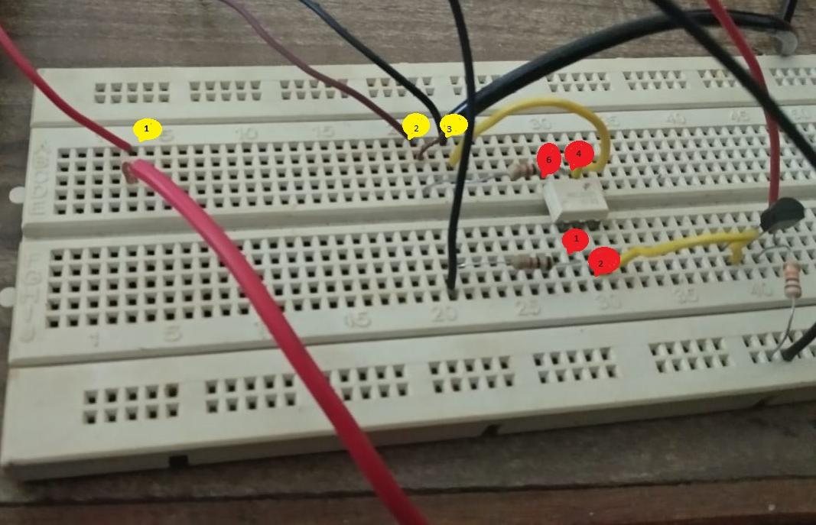

Here, 1,2,3 are the 3 terminals of Triac and 1,2,4,6 are the pins of optocoupler.

2nd pin of Triac is connected to one of the terminals of the bulb. A resister is also connected between 2nd pin of triac and 6th pin of optocoupler. 4th pin of optocoupler is connected to 3rd pin of triac. There is also a connection between 3rd pin of triac and 4th pin of optocoupler. 1st pin of triac is connected to live wire from power supply.

TRIAC is equivalent to two SCRs connected in inverse parallel with the gates connected together. As a result, the TRIAC functions as a Bidirectional switch to pass the current in both directions once the gate is triggered. TRIAC is a three terminal device with a Main terminal1 ( MT1), Main terminal 2( MT2) and a Gate. The MT1 and MT2 terminals are used to connect the Phase and Neutral lines while the Gate is used to feed the triggering pulse. The Gate can be triggered either by a positive voltage or negative voltage. When the MT2 terminal gets a positive voltage with respect to the MT1 terminal and the Gate gets a positive trigger, then the left SCR of the TRIAC triggers and circuit completes. But if the polarity of the voltage at the MT2 and MT1 terminals is reversed and a negative pulse is applied to the Gate, then the right SCR of Triac conducts.

The connections to optocoupler are shown in the diagram below

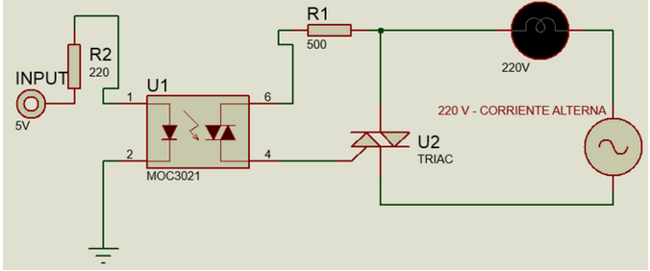

1. After connections are made, follow steps for setting up the raspberry pi.
2. Insert IP address of Raspberry Pi3 into host name.
3. In command window login with id as “pi” and password as “raspberry”.
4. Type "sudo raspi-config" and go to "Interfacing Options" and enable SSH and VNC.
5. Type the following two commands in Pi command prompt to update it. "sudo apt-get update" and "sudo apt-get upgrade".
6. Now follow steps to connect Amazon Echo to Raspberry Pi.
7. Enter "sudo python3 RPi_name_port_gpio.py" command to run Pi IOT program
8. Give voice command to Alexa to discover devices "Alexa discover devices" it will search your network and discover your Raspberry Pi 3 as an IOT device.
9. Connect GPIO pins to devices (here 25W bulb) connected to pin 11 of Raspberry Pi.
10. Give a voice command to Alexa "Turn on light1" and bulb will turn on
11. Give a voice command to Alexa "Turn off light1" and bulb will turn off.

The terminal window that appears is shown below:

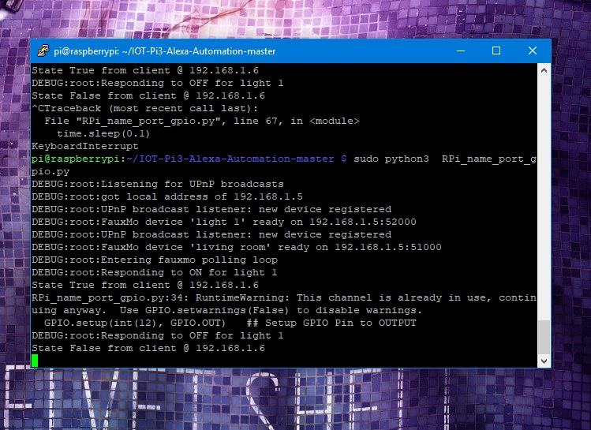

The entire Set up is as shown below

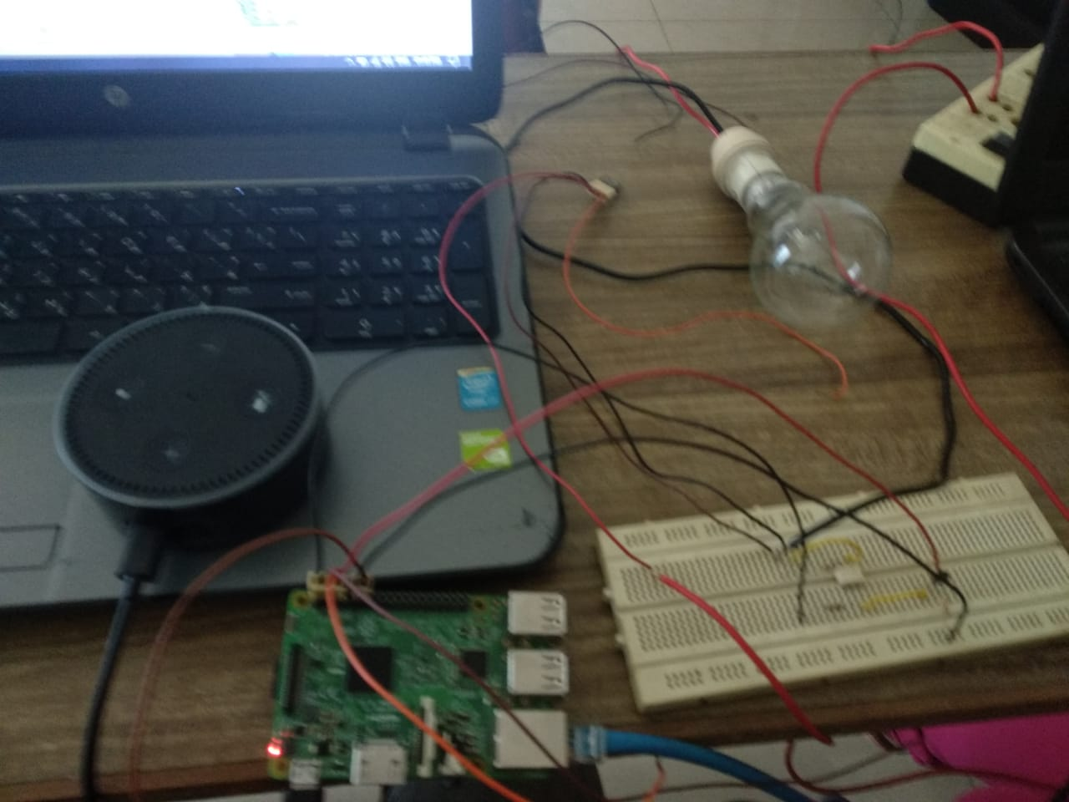

Therefore, we have successfully controlled a 25W bulb using raspberry Pi and Amazon Echo and provided effective isolation using an optocoupler connected with a TRIAC.